# DATABASE LAB MILESTONE 01

# REPORT DOCUMENTATION OF A VISIT TO A SOFTWARE HOUSE



Submitted By: DB Group:

* Hassan Bin Saqib 231170
* Abdul Moeez 231228
* Kamran Ahmed 231232

**BSAI-II-F-23-A**

**Submitted To:** Mam Asra

**Subject:** Database Lab (CS130L)

**Dated:** 18th February, 2024 (Sunday)

**Department of Creative Technologies (CT)**

**Air University Islamabad**

# INTRODUCTION:

Me Hassan, along with my group members Moeez and Kamran did a visit to a well established software House **“The IT Zon”.**

**IT ZON** is a software house specializing in developing and hosting mobile applications, During our visit, we gained valuable insights into their business processes, workflows, and did some interactions among their different departments persons. The organization comprises various entities, including HR, Accounts, QA Engineers, Graphic Designers, Developers, Project Managers, Marketing Department, and UI/UX Designers. Their primary revenue stream involves creating apps for the public and hosting them on platforms like the Play Store, with examples such as WhatsApp Saver, Qibla Direction Finder, Music Players, AI Chatbots, Image Generation Apps, Photo Editing Apps. Our analysis aims to identify opportunities where database systems can enhance efficiency, accuracy, and decision-making across the organization.

# BUSINESS PROCESSES AND WORKFLOWS:

# APP DEVELOPMENT PROCESS:

Project Planning:

Initiated by Project Managers, who identify app requirements and plan the project timeline.

## Design Phase:

UI/UX Designers collaborate to create the app layout and user experience.

Development Phase:

Developers write code based on the design specifications.

Testing Phase:

QA Engineers conduct both automated and manual testing to ensure app functionality and quality.

## Marketing and Hosting:

Marketers promote the app, and once internal testing is complete, it is hosted on platforms like the Play Store.

# ISSUE FIXING WORKFLOW:

Issue Identification:

Project Managers or QA Engineers identify app issues.

## Issue Resolution:

Developers resolve the issues by fixing bugs or improving functionalities.

## Testing:

QA Engineers conduct thorough testing to verify the fixes.

## Deployment:

Once the fixes pass internal testing, the updated app is deployed.

# INTERACTIONS BETWEEN DEPARTMENTS:

Project Managers liaise with all departments to ensure seamless coordination throughout the development lifecycle. Developers collaborate closely with UI/UX Designers to translate designs into functional code. QA Engineers interact with Project Managers and Developers to report and resolve issues. Marketers work in tandem with Project Managers to ensure timely app launches and effective promotion.

# INSIGHTS FOR DATABASE SYSTEM IMPLEMENTATION:

# PROJECT MANAGEMENT:

## Centralized Database:

Implementing a centralized database for project management can streamline communication and task allocation.

## Task Tracking:

A database system can facilitate real-time tracking of project tasks, enabling Project Managers to monitor progress efficiently.

# ISSUE TRACKING AND RESOLUTION:

## Ticketing System:

Utilizing a database-driven ticketing system can improve issue tracking, prioritization, and resolution.

Historical Data Analysis:

Storing issue resolution data in a database enables analysis of recurring issues and the effectiveness of solutions.

# QUALITY ASSURANCE:

## Test Case Management:

A database-driven test case management system can enhance QA processes by organizing test cases and tracking their execution.

Bug Database:

Maintaining a centralized bug database facilitates efficient tracking and resolution of software defects.

# MARKETING AND USER DATA ANALYSIS:

## User Analytics:

Implementing a database system for user analytics can provide valuable insights into user behaviour and preferences, aiding marketing strategies.

## Campaign Tracking:

Storing campaign data in a database enables marketers to analyze the effectiveness of different promotional strategies.

# CONCLUSION:

IT ZON operates in a dynamic environment, where efficient business processes and effective collaboration among departments are crucial for success. Implementing database systems across various functions can enhance efficiency, accuracy, and decision-making within the organization. By leveraging databases for project management, issue tracking, quality assurance, and marketing analysis, IT ZON can optimize its operations and deliver high-quality apps to its customers.Top of Form

# FIXING AN ISSUE FLOWCHART:

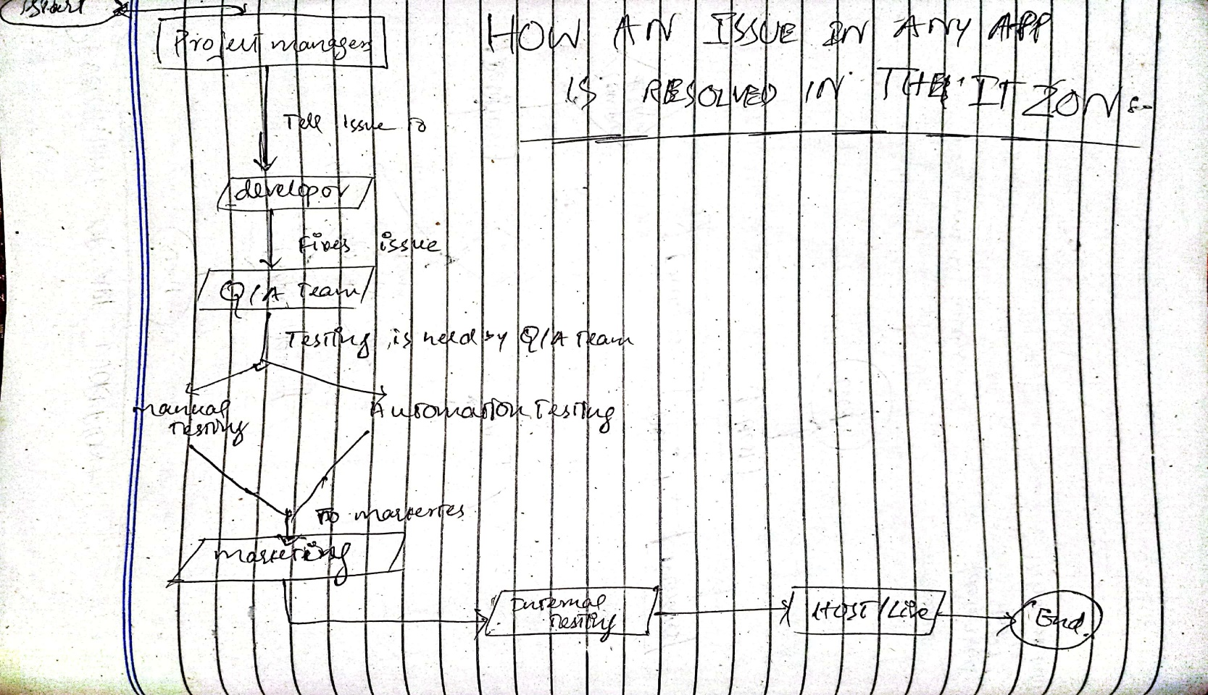

# DEVELOPMENT OF APP WORKFLOW:

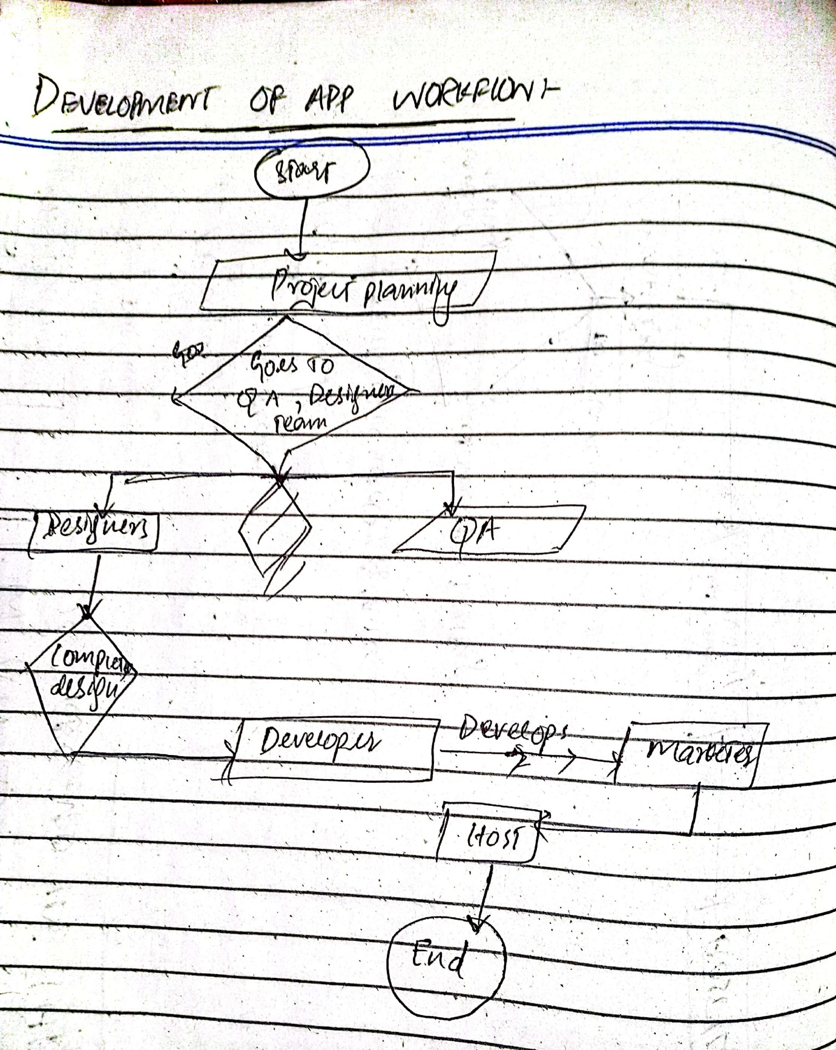

# Sample Invoices as a Proof:

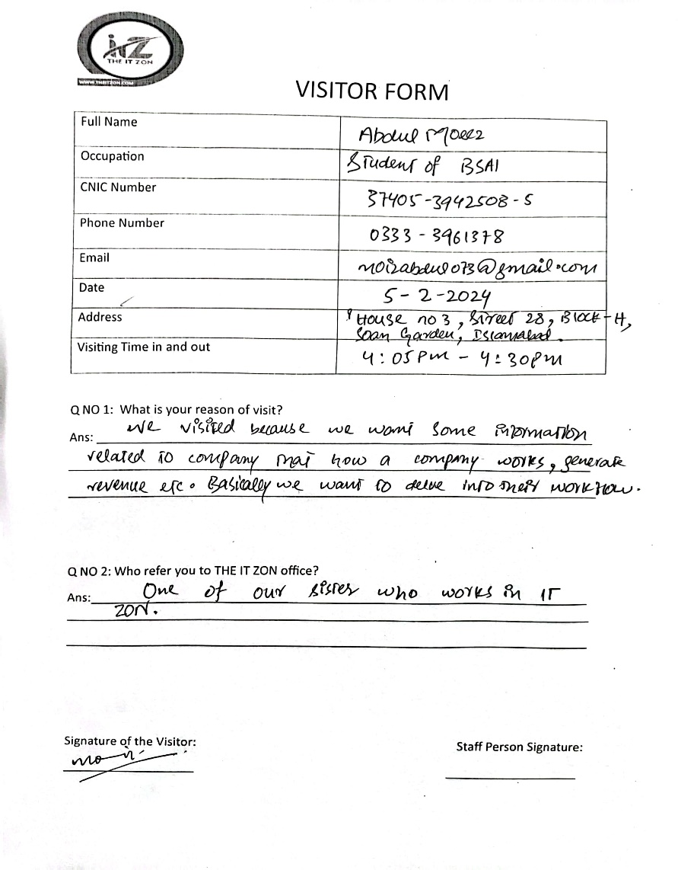Sorry to say but we were unable to gather company’s invoices as a proof of our visit because the company’s HR mentioned that it is against their company’s policies as they can’t share confidential/private information to others. So, we came up with an alternative. Following are the visitor’s form which we group members, filled as a result of our visit.

